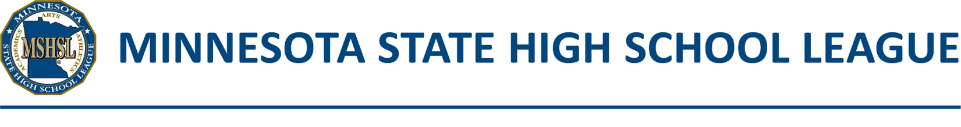

2020-2021 Fall Postseason Quarantine Form

The following student(s) has/have not tested positive for COVID-19, but are undergoing MDH-recommended quarantine periods due to contact with someone who has COVID-19 (MDH recommendation for contact with a known case). They are on the school’s preferred section roster, but due to timing of their quarantine, are not able to play in one or more initial section games. Their quarantine will be ending during the section tournament. These students are not currently under a physician’s care for their quarantine, therefore the approved physician-certified substitution policy does not apply.

Quarantined students who are on a school’s preferred section roster should be added to the section roster submitted to the section committee. They will then be temporarily replaced by the student(s) listed below. At the conclusion of the quarantine period, if the student has no additional risk or symptoms and has approval of the appropriate school professional (school nurse preferred), the student may be returned to the tournament squad. When such a player is returned to the tournament squad, the player replaces the substitute. At no time should a team squad exceed the maximum number of players dictated by section rules.

School: |  | Section/Class:
Activity:

Rostered player on quarantine | Start date of quarantine | End date of quarantine | Name of replacement player during quarantine

This form must be signed by the school’s Activities Administrator and submitted to the Section Manager prior to any games in which the quarantined player(s) will be replaced.

Signature of Activities Administrator |  | Date
☐ By checking this box and entering your name, you are confirming your signature electronically.

