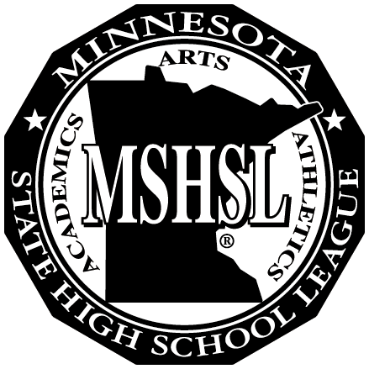MINNESOTA STATE

## MEMBER SCHOOLS

Alexandria

Becker

Bemidji

Big Lake

Brainerd

Buffalo

Detroit Lakes

Little Falls

Monticello

Moorhead

Rocori

St Cloud Apollo

St Cloud Tech

Sartell-St Stephen

Sauk Rapids-Rice

Willmar

HIGH SCHOOL

LEAGUE

Region 8AA

# John Ross, Exec. Sec. 329 21st Street North Sartell, MN 56377

# 320-290-3392 (cell) region8aajr@gmail.com

Region 8AA will hold their annual Fall Meeting at 9:00 am, Monday, September 27, 2021 at the Holiday Inn in Alexandria.

**AGENDA:**

Introductions – Region Chair Ben Kvidt, Alexandria AD

Additions to the agenda

July meeting minutes

MSHSL Update – Gary Revenig, 7AA-8AA Board Representative

MSHSL Update – John – Region Secretaries meeting, technology

Audit – in progress

Winter tournament recommendations – 8AAAA Basketball

Spring Tournament recommendations:

Golf Boys & Girls 8AAA- **John Ross**

Tennis Boys 8AA- **Dave Niemi, Becker**

Softball 5AAA- **Dave Niemi, Becker**

Softball 8AAA- **NaDean Schroeder, SRR**

Softball 8AAAA- **Eric Ruska, Tech**

Track Boys & Girls 5AA- **Open- Gary Revenig (Dave Wik)- Monticello**

Track Boys & Girls 8AA- **Ryan Blahosky, Willmar**

Track Boys & Girls 8AAA – **Dean Haugo, Moorhead**

Baseball 8AAA- **Rob Nielsen, Detroit Lakes**

Baseball 8AAAA- **Open**

Lacrosse Boys and Girls 8A- **Keith Cornell, STMA**

Fine Arts recommendations

Music – Seth Freundschuh

Visual Arts – Ben Kvidt

Fund balance maximum carry over is $77,000. Current balance $146, 800. Return $69,800

2 options to refund – Mileage allowance – split evenly

Spring Activity Advisory Proposals

Webcasting live – Fees

2020-21 Calendar Updates

Conflict Committee- review members

Section passes distributed

MNIAAA update - NaDean

Other Items (called for at beginning of meeting)