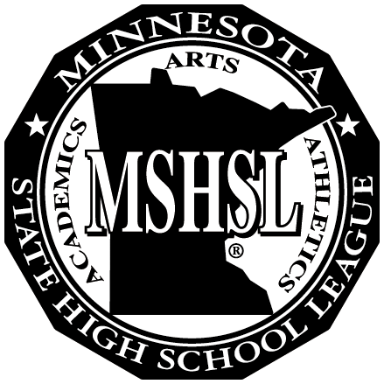MINNESOTA STATE

## MEMBER SCHOOLS

Alexandria

Becker

Bemidji

Big Lake

Brainerd

Buffalo

Detroit Lakes

Little Falls

Monticello

Moorhead

Rocori

St Cloud Apollo

St Cloud Tech

Sartell-St Stephen

Sauk Rapids-Rice

Willmar

HIGH SCHOOL

LEAGUE

Region 8AA

# John Ross, Exec. Sec. 329 21st Street North Sartell, MN 56377

# 320-290-3392 (cell) region8aajr@gmail.com

Region 8AA will hold their annual Spring Meeting at 9:00 am, Wednesday, April 20, 2022 at the Holiday Inn in Alexandria.

**AGENDA:**

Welcome, Introductions, identify voting committee members – Region Chair Ben Kvidt, Alexandria AD

Additions to the agenda

Welcome visitors – if any - 5 minutes max to speak on agenda item

January meeting minutes

MSHSL Update – Gary Revenig, 7AA-8AA Board Representative

MSHSL Update – Region Secretaries meeting 4/12/22- Ross

Transaction Report – January 1, 2022 to April 15, 2022 - Ross

Reconciliation Reports – January, February, March - Ross

5 Year Winter Tournament Comparison – Ross

Winter 2021-22 Summary – Adjustments?

8AAA Wrestling – Site, Time (Friday or Saturday)

Neutral Site Finals – feedback

Other?

AAA Banquet Review – Congrats to Kessa Mara – Willmar- Overall Winner AAA- Blahosky

Entry Fees – Speech – recommend $10 per entry - Ross

Spring Tournament calendar, procedures, tickets, etc. * AD Zoom work session- May 11?

Fall Sports- approval of fall dates and formats

Region Secretary Evaluation review and 2022-23 contract and salary. - Kvidt

Review spring sports dates, format, etc.

Future meeting date-July, location, time frame - approval winter, spring, Fine Arts dates

Verification of new committee members starting July 2021.

Fine Arts Updates

Winter advisory items – 11 – see attachment

Conflict Committee- review members

Other items added

Lunch