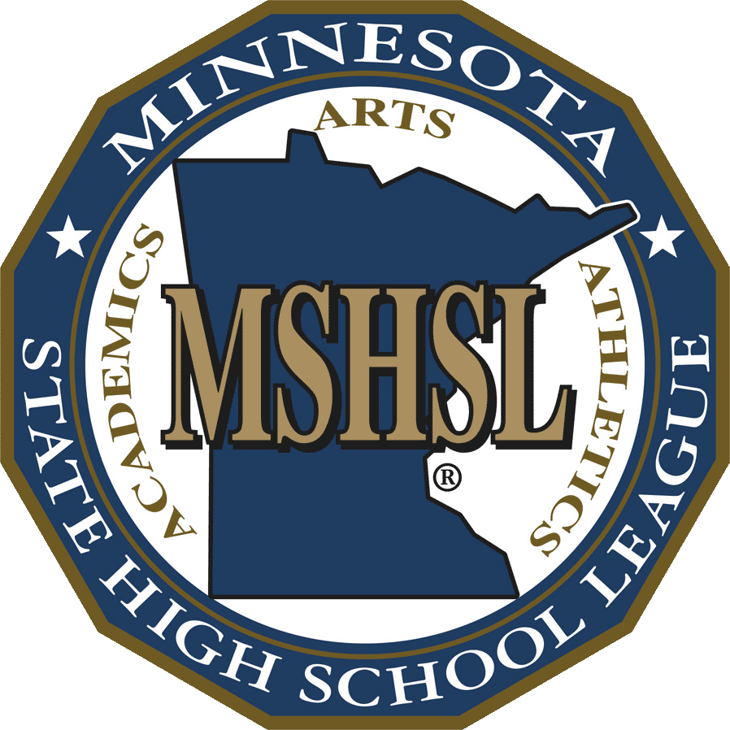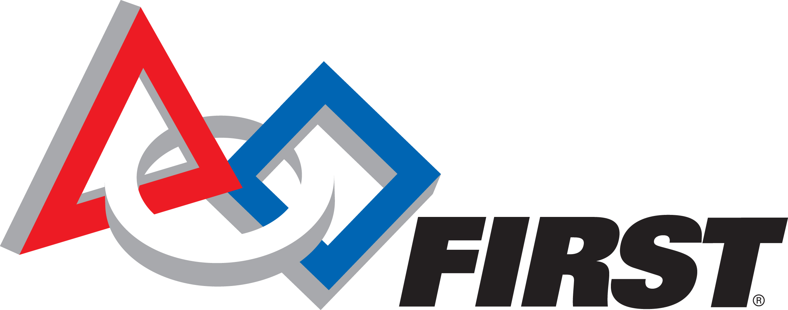2023-2024 MSHSL/FIRST

Robotics State Tournament

Eligibility Brochure
Note: MSHSL eligibility applies to the MSHSL/FIRST State Tournament, and not the season or competitions prior to the State Tournament. Any eligibility determinations regarding the FIRST season should be directed to FIRST personnel. Schools may choose to institute their own eligibility rules for participation in school-sponsored activities.

Students: Your participation in high school activities is dependent on your eligibility. PROTECT that eligibility by reviewing with your parent(s)/guardian(s) this summary of Minnesota State High School League rules which govern your participation. Complete regulations are found in the MSHSL Official Handbook which is available at each member high school and which is also posted on the MSHSL Website: www.mshsl.org/governance. Please keep this brochure for reference, and if there is a question about any rule interpretation, CONTACT YOUR SCHOOL PRINCIPAL OR ATHLETIC/ACTIVITIES DIRECTOR.
I understand I must sign the current eligibility statement prior to participation each school year. I understand that once I sign the eligibility statement all eligibility rules apply:
- 12 months of the year;
- Whether I am currently participating or not;
- Continuously from the first signing of the statement through the completion of my high school eligibility.

Parents/Guardians: REVIEW the following rules with your son or daughter. Your role in stressing the value of following these rules cannot be overstated.

General Student Eligibility Checklist (must be completed by all students) (If you cannot check all 7 items, contact your FIRST team advisor.

1. Making academic progress toward graduation.
2. Will not have turned 20 before the start of the season in which I participate.
3. Have not dropped out of school or repeated a grade beginning with the initial entrance in the 9th grade.
4. Have not and will not use or possess tobacco or alcoholic beverages, use, consume, have in possession, buy, sell or give away any other controlled substance, including steroids, drug paraphernalia or products containing or used to deliver nicotine, tobacco products and other chemicals.
5. Have not and will not violate the racial/religious/sexual harassment/violence/and hazing bylaws of the MSHSL.
6. I agree to fully cooperate in any investigation honestly and truthfully.
7. Regardless of my age I agree to follow all of the MSHSL Bylaws in order to be eligible to represent my school in League- sponsored activities.

GENERAL BYLAW REVIEW

All MSHSL eligibility determinations are based on bylaws found in the most current official handbook
or on the MSHSL website at: www.mshsl.org/governance

- *ACADEMIC — (Credit Requirement) To be eligible, a student must be making satisfactory progress toward the school’s requirement for graduation.
- *AGE — A student who turns 20 during the 11th or 12th semester since first entering the 7th grade shall be allowed to participate through the completion of the 12th semester. Adapted athletes are eligible to participate until their 22nd birthday, provided they meet all other eligibility requirements.
- AMATEUR STATUS — A student must be an amateur in that sport. A student may not receive cash or merchandise for athletic participation. A student does not lose her/his amateur status because of reimbursement for officiating, instructing, teaching or coaching a sport. (Reference Bylaw 201 for further amateur provisions)
- AWARDS — Acceptable awards to students in recognition of participation in high school activities include medals, ribbons, letters, trophies, plaques and other items of little or no intrinsic value ($100.00 or less). Violation will render a student ineligible for participation in that activity.
- *ENROLLMENT, ATTENDANCE, AND REQUIRED SUBJECT LOAD — Students must be fully enrolled in (as defined by the Minnesota Department of Education) and attending the school before they are eligible to represent that school in MSHSL sponsored activities. Students must be properly registered, attending school and classes regularly. Students must be on track to meet the school’s graduation requirements in six years (12 consecutive semesters) beginning with the first day of attendance in the 7th grade.
- FOREIGN EXCHANGE STUDENTS — Approved Foreign Exchange Students are eligible.
7. *GENERAL ELIGIBILITY — In order to be eligible for regular season and MSHSL tournament competition, a student must be fully enrolled as defined by the Minnesota Department of Education and a bona fide member of his or her high school in good standing. A student who is under penalty of exclusion, expulsion or suspension, whose character or conduct violates the Student Code of Responsibilities and is not in good standing, shall be ineligible for a period of time as determined by the principal.

Student Code of Responsibilities
As a student participating in the MSHSL/FIRST Robotics State Tournament, I understand and accept the following responsibilities:
- I will respect the rights and beliefs of others and will treat others with courtesy and consideration.
- I will be fully responsible for my own actions and the consequences of my actions
- I will respect the property of others.
- I will respect and obey the rules of my school and the laws of my community, state and country.
- I will show respect to those who are responsible for enforcing the rules of my school and the laws of my community, state and country.
8. *SEASONS OF PARTICIPATION — No student may participate in more than six (6) seasons in any activity while enrolled in grades 7-12, semesters 1-12 inclusive.
9. *SEMESTERS ENROLLED — Each student is eligible for participation in League-sponsored athletic activities for four consecutive school years beginning with their initial entrance into ninth grade.
10. JUNIOR HIGH/MIDDLE SCHOOL PARTICIPATION — Participation in high school interscholastic programs is limited to students in grades 7-12 inclusive. Students in grade 7, 8 and 9 may participate if enrolled in the regular continuation school for the educational unit and if all other eligibility requirements of the League have been met. Elementary students in grades 1-6 are not eligible for participation in any MSHSL-sponsored activity; B-squad, junior varsity or varsity level.
11. *GRADUATE — Students who have graduated from a secondary school, or who have completed the terminal or final grade of a secondary school, or who have earned a GED or diploma are not eligible for participation in any League activity A student who graduates while a member of a team with a season in progress may complete the season if three or fewer weeks of the regular season, exclusive of League tournament play, remain.
12. *MOOD-ALTERING CHEMICALS
- Reference Bylaw 205
Twelve (12) months of the year, a student shall not at any time, regardless of the quantity:
• use or consume, have in possession a beverage containing alcohol;
• use or consume, have in possession tobacco;
• use or consume, have in possession, buy, sell, or give away any other controlled substance or drug paraphernalia,
• use or consume, have in possession, buy, sell or give away products containing, or products used to deliver nicotine tobacco products and other chemicals.
“Tobacco products” means: any product containing, made, or derived from tobacco that is intended for human consumption, whether chewed, smoked, absorbed, dissolved, inhaled, snorted, sniffed, or ingested by any other means, or any component, part or accessory of a tobacco product, (5) use or consume, have in possession, buy, sell or give away any substance or product where the intent of such use of the substance or product is to induce intoxication, excitement, or stupefaction of the central nervous system, except under the direction and supervision of a medical doctor. Such substance or products shall include, but are not limited to, synthetic drugs, gasoline, glue, aerosol devices, bath salts, and any substances addressed by Minnesota or Federal law.
1. The bylaw applies continuously from the first signing of the student Eligibility Brochure.
2. It is not a violation for a student to be in possession of a controlled substance specifically prescribed for the student’s own use by her/his doctor.
B. Penalty:
- First Violation: After confirmation of the first violation, the student shall lose eligibility for the next two (2) consecutive interscholastic contests or two (2) weeks of a season in which the student is a participant, whichever is greater. No exception is permitted for a student who becomes a participant in a treatment program.
- Second Violation: After confirmation of the second violation, the student shall lose eligibility for the next six (6) consecutive interscholastic contests in which the student is a participant or three (3) weeks, whichever is greater. No exception is permitted for a student who becomes a participant in a treatment program.
- Third and Subsequent Violations: After confirmation of the third or subsequent violations, the student shall lose eligibility for the next twelve (12) consecutive interscholastic contests in which the student is a participant or four (4) weeks, whichever is greater. If after the third or subsequent violations, the student has been assessed to be chemically dependent and the student on her/his own volition becomes a participant in a chemical dependency program or treatment program, then the student may be certified for reinstatement in MSHSL activities after a minimum period of six (6) weeks. Such certification must be issued by the director or a counselor of a chemical dependency treatment center
- .Penalties are progressive and consecutive.
- Denial Disqualification: A student shall be disqualified from all inter-scholastic athletics for nine (9) additional weeks beyond the student’s original period of ineligibility when the student denies violation of the rule, is allowed to participate and then is subsequently found guilty of the violation.
13. *SEXUAL/RACIAL/RELIGIOUS HARASSMENT/VIOLENCE and HAZING
A. Reference Bylaw 209.00:
student shall not engage in the sexual, racial, religious harassment, violence or hazing during the school year or any portion of an activity season that occurs prior to the start of the school year or after the close of the school year.
B. Reporting Procedures:
- Any person who believes he or she has been the victim of sexual, racial, religious harassment, violence or hazing or any person with knowledge or belief of conduct, which may constitute hazing, shall report the alleged acts immediately to an appropriate school district official designated by this policy.
- The building principal is the person responsible for receiving reports of sexual, racial, religious harassment, violence or hazing at the building level. Any person may report hazing directly to a school district human rights officer or to the superintendent.
- Teachers, administrators, officials, volunteers, and employees of the school district shall be particularly alert to possible situations, circumstances or events which might include sexual, racial, religious harassment, violence or hazing. Any such person who receives a report of, observes, or had other knowledge or belief of conduct, which may constitute sexual, racial, religious harassment, violence or hazing, shall inform the building principal immediately.
- Submission of a good faith complaint or report of sexual, racial, religious harassment, violence or hazing will not affect the complainant or reporter’s future employment, grades or work assignments.

C. Reprisal
The school district will discipline or take appropriate action against any student, teacher, administrator, volunteer, coach, official contractor or employee of the school district who retaliates against any person who makes a good faith report of alleged sexual, racial, religious harassment, violence or hazing or against any person who testifies, assists, or participates in an investigation, or against any person who testifies, assists or participates in a proceeding or hearing relating to such sexual, racial, religious harassment, violence or hazing. Retaliation includes, but is not limited to, any form of intimidation, reprisal or harassment.
D. Penalties for Category I Activities:
- First Violation: the student shall lose eligibility for the next two (2) consecutive interscholastic contests or two (2) weeks, 14 calendar days, of a season in which the student is a participant, whichever is greater. Recommendations:
  - It is recommended that the school develop a local education program through which the student would receive information about sexual, racial, religious harassment, violence or hazing.
  - 2) It is recommended that, when appropriate, the school refer a student to a community agency or a professional individual outside the school for counseling.
- Second Violation: the student shall lose eligibility for the next six (6) consecutive interscholastic contests or three (3) weeks, 21 calendar days, whichever is greater, in which the student is a participant. Recommendation: It is recommended that before being re-admitted to activities following suspension for the second violation, the student shall show evidence in writing that the student has received counseling from a community agency or professional individual such as a school counselor, medical doctor, psychiatrist, or psychologist.
- Third or Subsequent Violations: the student shall lose eligibility for the next twelve (12) consecutive interscholastic contests or four (4) weeks, 28 calendar days, whichever is greater, in which the student is a participant.
- Penalties are progressive and consecutive.
E. Penalties for Category II Activities:
Each member school shall develop penalties that it will apply to the participants in these activities. A current copy of the member school’s policy shall be kept on file in the member school.
14. SERVING A MSHSL PENALTY — A student must be a student in good standing, and able to be placed in the game, meet or contest except for the penalty being served. (Students who are not in good standing due to suspension, expulsion, injury, illness, family vacations, etc. are not able to be placed in a game, meet or contest and are therefore not able to count those contests toward the penalty).
15. PROGRESSIVE AND CONSECUTIVE Penalties: Penalties shall be progressive and consecutive beginning with the student’s first participation in a League activity and continuing through the student’s high school career.
16. COLLEGE/UNIVERSITY TEAMS — Individuals who have participated with a college or university team are ineligible for participation in any activity of the League.
17. FAIR HEARING PROCEDURE — The League Constitution provides a Fair Hearing Procedure for the student or parent contesting a school’s determination of ineligibility for a student. The student has 10 calendar days in which to appeal the school’s decision. The appeals process includes an appeal before a hearing panel at the school and the right, if desired, to appeal that decision to the League’s Board of Directors. An independent hearing examiner will hear the appeal and make written findings of fact, conclusions and a recommendation for the Board of Directors following the hearing. The Board’s decision shall be final. A complete listing of the Fair Hearing Procedure may be obtained from the athletic director or principal of the high school or at www.mshsl.org/governance.

2023-2024 MSHSL/FIRST Robotics State Tournament Eligibility Statement
All MSHSL eligibility determinations are based on the most current official handbook on the MSHSL website at: www.mshsl.org/governance

Statement to be signed by the participant from a MSHSL member school and by the participant’s parent or guardian each school year prior to participation in that year.
Please check all items:
I have read, understand, and acknowledge receiving the 2023-2024 MSHSL Eligibility Brochure, which contains only a summary of the eligibility rules of the Minnesota State High School League. I understand that a copy of the Official Handbook of the MSHSL is on file with the senior high school athletic director and or principal and that I may review it, in its entirety, if I so choose.

I understand that once I sign the eligibility statement all eligibility rules apply:
-- Twelve (12) months of the year;
-- Whether I am currently participating or not;
-- Continuously from the first signing of the statement through the completion of my high school eligibility.

Regardless of my age I agree to follow all of the MSHSL Bylaws in order to be eligible to represent my school in League- sponsored activities.

I further understand that a member school of the MSHSL must adhere to all of the rules and regulations that pertain to the League activities a school may sponsor and that local rules may be more stringent, and penalties more severe, than MSHSL rules.

STUDENT CODE OF RESPONSIBILITIES
As a student participating on a FIRST Robotics team eligible for the MSHSL/FIRST State Robotics Tournament, I understand and accept the following responsibilities:
-- I will respect the rights and beliefs of others and will treat others with courtesy and consideration.
-- I will be fully responsible for my own actions and the consequences of my actions.
-- I will respect the property of others.
-- I will respect and obey the rules of my school and the laws of my community, state and country.
-- I will show respect to those who are responsible for enforcing the rules of my school and the laws of my community, state and country.
A student whose character or conduct violates the Student Code of Responsibilities or is suspended or expelled is not in good standing and is ineligible for a period of time as determined by the principal. While a student not in good standing, a student may not serve any penalty for MSHSL Bylaw violations.

Informed Consent: By its nature, participation in interscholastic athletics includes risk of injury and the transmission of infectious diseases such as HIV, Herpes and Hepatitis B and others. Although serious injuries are not common, and the risk of HIV transmission is almost nonexistent in supervised school athletic programs, it is impossible to eliminate all risk. Participants have the responsibility to help reduce that risk. Participants must obey all safety rules, report all physical and hygiene problems to their coaches, follow a proper conditioning program, and inspect their own equipment daily. PARENTS, GUARDIANS OR STUDENTS WHO MAY NOT WISH TO ACCEPT THE RISK DESCRIBED IN THIS WARNING SHOULD NOT SIGN THIS FORM. STUDENTS MAY NOT PARTICIPATE IN AN MSHSL-SPONSORED ACTIVITY WITHOUT THE STUDENT’S AND PARENT’S/GUARDIAN’S SIGNATURE.

I consent to the athletic trainer or coach treating injuries and authorize them to discuss those injuries with and release any applicable medical information or records relating to those injuries to coaches, school staff and other qualified health care providers as deemed necessary within their scope of practice.

I further understand that in the case of injury or illness requiring transportation to a health care facility, that a reasonable attempt will be made to contact the parent or guardian in the case of the student-athlete being a minor, but that, if necessary, the student will be transported via ambulance to the nearest hospital.

By signing this we acknowledge that we have read the information contained in the MSHSL Eligibility Brochure and Statement.

I/we acknowledge the electronic signature confirms I/we have read and reviewed the information contained in the contents of the Eligibility Brochure and Statement. I/we also acknowledge this electronic signature has the same legal effect, validity, and enforceability as a signature in a non-electronic form.
The student/parent authorizes the release of documents and other pertinent information by the school in order to determine student eligibility. In addition, the student/parent understands and agrees that public information shall include names and pictures of students participating in or attending extra-curricular activities, school events, and High School League activities or events.

Student’s Printed Name Birth Date Grade in School

Student’s Signature Date

Parent’s or Guardian’s Signature Date

This statement should be kept on file with the Robotics team advisor or at the school’s activities office, if applicable.

